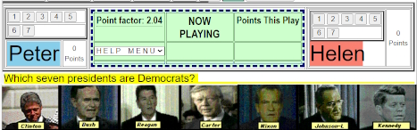
In the above image, the Question is to click-on the Seven Democrats in a grid of 16 former US Presidents. [Only the top seven are shown to save space]
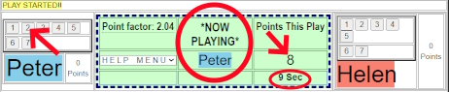
In the above image, Peter has bid for 2 and has pressed the “2” button. The Potential Points are set at 8 [2 squared X 2.04 Point Factor] and he now has 9 seconds to accomplish the task.
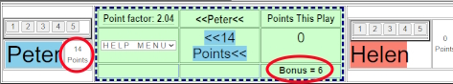
In the above image, Peter has received 14 Points. [8 points for getting 2 right plus 6 Bonus Points for answering quickly.
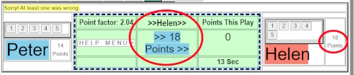
In the above image, Peter tried for 3 more presidents and missed at least one. The result is that Helen go 18 Points [3 squared Times 2.04 Point Factor]

